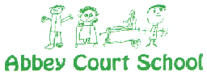

**Pupil Premium Grant Expenditure**

**Report to Governors: September 2021**

School Context

Table 1

|  |  |  |  |  |  |  |  |  |  |  |  |
| --- | --- | --- | --- | --- | --- | --- | --- | --- | --- | --- | --- |
| **Pupil information** | | | | | | | | | | | |
|  | **2011/12** | **2012/13** | **2013/14** | **2014/15** | **2015/16** | **2016/17** | **2017/18** | **2018/19** | **2019/20** | **2020/21** | **2021/22** |
| No of pupils on roll | 140 | 135 | 140 | 138 | 145 | 136 | 141 | 163 | 164 | 182 | 194 |
| No of pupils eligible for PPG | 43 | 58 | 57 | 52 | 53 | 64 | 51 | 45 | 46 | 54 | 50 |
| % of pupils eligible for PPG | 31% | 43% | 41% | 38% | 37% | 47% | 36% | 28% | 28% | 30% | 26% |

*NB: The reduction in the percentage of pupils eligible for Pupil Premium funding between 2017/18, 2019/20, and 2020/21 is attributed to a decrease in Free School Meal eligibility and an increase in overall pupil numbers in the school. In addition, there are fewer Early Years pupils attracting the funding, predominantly because of Universal Infant Free School Meals.*

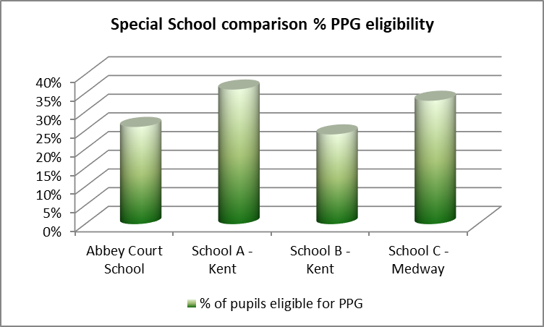





* 2011/12 – underspend of 0.5% *(£89 carried forward to 2012/13)*
* 2012/13 – underspend of 1.1% owing to savings on equipment purchasing *(£429 carried forward to 2013/14)*
* 2013/14 – overspend of 2.8% *(£0 carried forward to 2014/15)*
* 2014-15 – overspend of 1.7% *(£0 carried forward to 2015/16)*
* 2015-16 – overspend of 34.8% (£0 carried forward to 2016/17)
* 2016-17 – overspend of 3.3% (£0 carried forward to 2017/18)
* 2017-18 – underspend of 3.4% owing to savings on equipment purchasing *(£1,857 carried forward to 2018/19)*
* 2018-19 – underspend of 6.7% owing to saving on PE teacher salary
* 2019-20 – underspend of 6.2% owing to Covid 19 and the cancellation of residential and other activities.
* 2020/21 – overspend of 0.2% (£0 carried forward to 2021/22)
* *2021/22 - figures currently report proposed income and expenditure*

NB: Figures from 2015/16 onwards include Year 7 Catch Up allocations of £5,500 (2015/16), £4,125 (2016/17), £3,208 (2017/18), £3,208 (2018/2019) and £8,707 (2019/2020). In 2020/21 Year 7 Catch Up funding was replaced by Covid Catch Up funding (£25,690), which was 2/3 payment of an expected £37,440 total allocation.

|  |
| --- |
| **PG spending** |
| **Overall Aim**  **To raise attainment and achievement of pupils and ensure good or better progress:**  Spending PPG is based on analysis of barriers to learning:  *(Based on the expectation that all children will make at least ‘good or better’ progress)*  *Assessment data tracks all “vulnerable group” pupils including those in PPG, which then informs planning appropriate provision. (Class IEPs provide individual detail.) Individual Pupil Progress meetings with teachers track pupil achievement and link directly into staff Performance Management reviews.* |

Pupil Premium Data Sheet   
At the beginning of each term (3 times per year), a multi-professional pupil progress meeting (PPM) is held during which the progress of each pupil receiving Pupil Premium funding is considered. Their progress across the curriculum is scrutinised including any Individual Education Plan (IEP) targets, and areas that require improvement are identified. The PPM then considers strategies that will effectively move these pupils on and the best approach (additional Speech and Language Therapy; individual teaching; equipment/aids etc.) that will support the pupil.

The following chart gives an overview of PP pupil information (the green columns and comments column).

At the end of the academic year the schools progress tracker details the progress that pupils have made in all areas of the curriculum. This enables us to look at pupil progress in relation to their interventions. For the purpose of this report, we identify whether pupils have made good or better progress (the yellow boxes), or whether their progress requires improvement (the dark grey boxes in the end columns). This enables us to evaluate the impact and consider next steps for the pupil.

|  |  |  |
| --- | --- | --- |
| **Summary of Spend** | | |
| **Year** | **Cost (£)** | **% spend** |
| **2011/12**  Equipment  40 iPads & related software  2 Charging Units & Protective Cases for iPads | 15,981  3,450 |  |
| **TOTAL** | 19,431 | 99.5% |
|  | | |
| **2012/13**  Equipment  Isis Flipscreen Desk & 102 Desk  Protective Cases for iPads  20 iPad Retina Display & Charging Unit – RM Education  iTune Vouchers for iPads  1:1 Support  Myst Size 2 Stander – James Leckey (D.C.)  Myst Size 1 Stander – James Leckey (S.K.)  LPS Size 2 Pronestander – James Leckey (T.P.)  T80 Paediatric Shower & Toileting Chair – Wealdon Rehab (Y.C.)  Salaries  Therapist Support Staff salaries  Training  Intensive Interaction training (K.K.) | 1,179  451  11,787  476  1,881  1,759  1,014  2,104  14,439  4,300 |  |
| **TOTAL** | 39,390 | 98.9% |
|  | | |
| **2013/14**  Equipment  7 iPads & Cases – Toucan Computing  1:1 Support  Mygo Size 1 Seating System – James Leckey (K.L.)  Mygo Size 2 Seating System – James Leckey (D.C.)  Lightwriter SL40 – Toby Churchill (M.M.)  Large frame red pacer – Jenx (K.A.)  ACE Centre Service Level Agreement  Salaries  Art Therapist salary (7/12)  Occupational Therapy Assistant salary  Speech & Language Therapy Assistant salary  Training  Delivery of Rebound Therapy training  Intensive Interaction training | 2,093  2,312  2,611  3,200  2,209  5,000  15,289  12,725  15,596  1,034  4,300 |  |
| **TOTAL** | 66,369 | 102.8% |
|  | | |
| **2014/15**  Equipment  9 x ipads & Cases – Toucan Computing  Consumable lesson resources  Wheelchair Loader Bike – Quest 88  1:1 Support  Consultancy re IEP progression for individual pupils  Mygo Size 1 Seating System – James Leckey (K.L.)  Mygo Size 1 Seating System – James Leckey (S.K.)  EDS Size 2 Seating System – James Leckey (H.B.)  Neater Eater – Neater Solutions Ltd (J.W.)  Study Carrells – KCS  Lightwriter SL40 – Toby Churchill (M.M.)  Equipment fittings – Mounts & More (K.L.)  Easybans Standing Frame– James Leckey (B.M.)  Salaries *(see table below)*  Proportion of Art Therapist salary  Proportion of Occupational Therapy Assistant salary  Proportion of Speech & Language Therapy Assistant salary  Proportion of Music Therapist salary  Proportion of Physiotherapist salary  Curriculum Enhancement  Horse riding – 18 pupils x 10 sessions @ £10 contribution  Horse riding – cover of parental contribution (P.M-B.) | 2,556  11  5,776  5,166  2,312  2,501  1,797  1,214  1,173  3,200  489  3,913  12,223  6,943  6,851  3,380  6,237  1,800  110 |  |
| **TOTAL** | 67,652 | 101.7% |
| Calculation of proportionate salaries:-   |  |  |  |  |  |  |  |  | | --- | --- | --- | --- | --- | --- | --- | --- | | **2014/15** | **Salary** | **Total no. of pupils seen** | **No. of Pupil Premium** | **PP Double weighted** | **Allocation per pupil** | **Total cost for PP pupils** | **Proportion of cost covered from PP funding** | | OT (Asst) | 15,712 | 43 | 19 | 38 | £365.40 | £13,885.20 | £6,942.60 | | Physio | 24,947 | 44 | 11 | 22 | £566.98 | £12,473.56 | £6,236.78 | | SALT (Asst) | 15,842 | 74 | 32 | 64 | £214.08 | £13,701.19 | £6,850.56 | | Music | 10,366 | 46 | 15 | 30 | £225.35 | £6,760.50 | £3,380.25 | | Art | 27,065 | 31 | 14 | 28 | £873.06 | £24,445.68 | £12,222.84 | | Total salaries | 93,932 |  | | | | | | | | |
| **2015/16**  Equipment  Magnetic folding tent whiteboard  Magnetic symbols and shapes  Vibrating teether  Super chewy  Beinn 26 large bike (JP.J.J.T)  1:1 Support  Consultancy re IEP progression for individual pupils  ACE Centre Service Level Agreement  Salaries *(see table below)*  Proportion of Art Therapist salary  Proportion of Occupational Therapy Assistant salary  Proportion of Speech & Language Therapy Assistant salary  Proportion of Music Therapist salary  Proportion of Physiotherapist salary  Curriculum Enhancement  Horse riding – 70 sessions @ £20 per session (cost & parental contribution) | 22  90  43  90  1,214  20,223  5,000  17,526.88  10,093.29  6,085.53  15,231.00  19,053.00  1,400 |  |
| **TOTAL** | 96,071.70 | 134.8% |
| Calculation of proportionate salaries:-   |  |  |  |  |  |  |  |  | | --- | --- | --- | --- | --- | --- | --- | --- | | **2015/16** | **Salary** | **Total no. of pupils seen** | **No. of Pupil Premium** | **PP Double weighted** | **Allocation per pupil** | **Total cost for PP pupils** | **Proportion of cost covered from PP funding** | | OT (Asst) | 19,641 | 72 | 37 | 74 | £272.79 | £20,186.58 | £10,093.29 | | Physio | 28,251 | 43 | 29 | 58 | £657.00 | £38,106.00 | £19,053.00 | | SALT (Asst) | 16,344 | 94 | 35 | 70 | £173.87 | £12,171.06 | £6,085.53 | | Music | 30,462 | 72 | 36 | 72 | £423.08 | £30,462.00 | £15,231.00 | | Art | 28,043 | 32 | 20 | 40 | £876.34 | £35,053.75 | £17,526.88 | | Total salaries | 122,741 |  | | | | | | | | |
| **2016/17**  Equipment  Neater Eater (BM)  Super Chewy  Year 7 Catch Up various KCS resources  Alphabet cards/Unifix cubes  Sensory shapes/phonics resources  1:1 Support  Consultancy re IEP progression for individual pupils  Salaries *(see table below)*  Proportion of Art Therapist salary  Proportion of Physiotherapist salary  Curriculum Enhancement  Callum Park horse riding (cost & parental contribution)  Jumpers Rebound trampolining (cost & parental contribution) | 1,105  90  4,539  94  94  14,831  19,446  19,604  4,610  1,738 |  |
| **TOTAL** | 66,151 | 103.3% |
| Calculation of proportionate salaries:-   |  |  |  |  |  |  |  |  | | --- | --- | --- | --- | --- | --- | --- | --- | | **2016/17** | **Salary** | **Total no. of pupils seen** | **No. of Pupil Premium** | **PP Double weighted** | **Allocation per pupil** | **Total cost for PP pupils** | **Proportion of cost covered from PP funding** | | Physio | 29,068 | 43 | 29 | 58 | £676.00 | £39,208.00 | £19,604.00 | | Art | 31,114 | 32 | 20 | 40 | £972.31 | £38,892.50 | £19,446.25 | | Total salaries | 60,182 |  | | | | | | | | |
| **2017/18**  Equipment  Resources to support learning  1:1 Support  Consultancy re IEP progression for individual pupils  Riding Instructor (horse simulator)  Curriculum Enhancement  Callum Park horse riding  Jumpers Rebound trampolining | 10,206  32,164  4,700  4,140  1,656 |  |
|  | 52,866 | 96.6% |
| **2018/19**  Equipment  Resources to support learning – Year 7 Catch up  English Scheme of Work – Reading  PSHE Healthy Living Activity Set  PSHE Male and Female Repro Displays  Acheeva bed  1:1 Support  Consultancy re IEP progression for individual pupils  Phonics 1:1 support  Riding Instructor (horse simulator)  PE Teacher (secondary pupils only)  Curriculum Enhancement  Callum Park, Squirrels, Arrow Riding, horse riding  Jumpers Rebound trampolining  Residential visits  Staff Training  Lego Team Building  Phonics Curriculum  PECs  Improving Education for CHIN  Child Mental Health and Wellbeing  Observing SEN Lessons  Hydropool Rescue  PSHE  The Cutting Edge  The Role of the Subject Leader  TEACCH  Understanding VI | 3,208  907  182  108  5,381  12,929  10,084  2,444  7,051  1,104  1,726  512  3,120  750  567  235  299  299  607.50  245  810  975  1592  236 |  |
|  | 55,372 | 93.2% |
| **2019/2020**  Equipment  Resources to support learning – Year 7 Catch up  Sensory resources and equipment  Home learning resources  1:1 Support  Reading 1:1 Support  Music 1:1 Support  OT 1:1 Support  Speech & Language Therapy 1:1 Support  Riding Instructor (horse simulator)  Massage therapy  Rebound therapy  Curriculum Enhancement  Arrow Riding / Squirrels horse riding  Jumpers Rebound trampolining  Offsite swim  Staff Training  Rebound Therapy Trainers course x 2  Rebound Therapy Train the Trainer course  Tac Pac  TEACCH  Sensory Reading  Development of Early Reading | 8,707  14,204  2,508  5,652  2,291  684  1,206  6,598  234  4,122  2,108  2,020  622  2,878  3,415  600  1,628  1,250  1,000 |  |
|  | 61,727 | 93.7% |

|  |  |  |
| --- | --- | --- |
| **2020/2021**  Equipment  Sensory resources/equipment and home learning resources  1:1 Support  Reading 1:1 Support  Music 1:1 Support  OT 1:1 Support  Draw and Talk  Riding Instructor (horse simulator)  Curriculum Enhancement  Not applicable owing to Covid-19 restrictions | 54,362  8,856  1,470  2,676  144  576  0 |  |
|  | 68,084 | 100.2% |

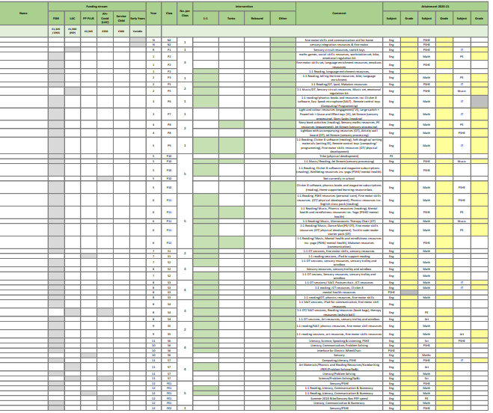

The table above shows the 50 designated Pupil Premium pupils for 2020/21, and the outcomes in terms of the impact on their progress.

In the 122 subjects related to provision, 98% were Good or Outstanding progress (colour coded in yellow), leaving 2% graded as Requires Improvement (in grey). The pupils who require improvement have been discussed through pupil progress meetings and alternative strategies, along with new targets, have been agreed for them and will be monitored continually over the coming year, with a termly review to check on progress. Each pupil has a target related to their subject(s) requiring improvement and these are also being supported and monitored by the subject leaders working with the class teachers. It is important to note that one of these pupils has not attended school this academic year. Additionally, the other pupil, had made Good or Outstanding progress in their two other focus subjects.

Catch Up Premium 2020-2021

Covid-19

In June 2020 the government announced £1 billion of funding to support children and young people to catch up on missed learning caused by coronavirus (COVID19). This is especially important for the most vulnerable pupils and pupils from disadvantaged backgrounds who we know have been most affected. Abbey Court School anticipates the receipt of £37,440 in Covid-19 Catch Up Premium allocations. This is to be paid in 3 tranches between Autumn 2020 (£9,360), and Summer 2021 (28,080). This funding will be used to provide Speech and Language Therapy at a cost of £30,192 for the year, with the remainder (£7,248) being spent on Educational Psychology.

|  |  |  |
| --- | --- | --- |
| Term: | Money received: | Allocation of funding |
| Autumn 2020 | £9360 | * Increased specialist SALT support |
| Spring 2021 | £16330 | * Increased specialist SALT support * Specialist Educational Psychologist (support for identified individual pupils) |
| Summer 2021 | £11750  (Expected July 2021) | * Increased specialist SALT support |

Commentary:

It was identified that additional Speech and Language Therapy support would have a positive impact, and was relevant to promoting the progress of all pupils at Abbey Court. In addition to this, progress in communication, enables pupils to make progress across all areas of the curriculum. In 2020-21, 97% of pupils made Good or better progress in Speaking and Listening, with 12% making Outstanding progress in Speaking. Additionally, 98% of pupils made Good or better progress in Reading and Writing. This is an improvement on 2019-20 progress, where 96% of pupils achieved Good or better progress in Speaking, 96% in Reading and 95% in Writing.

It was additionally felt that some individual pupils would benefit from additional support from an Educational Psychologist, to support their mental health and wellbeing and behaviour needs. These pupils were identified during pupil progress meetings and in consultation with parents. The outcomes of this support have been shared with families and class teachers to ensure strategies enable ongoing progress, beyond the individual sessions.